2x2 Binary Muliplier:

3x3 Binary Multiplier:

Half Adder:

Full Adder:

Half Subtractor:

Full Subtractor:

one-bit comparator:

74148 (8 x 3) Octal to Binary Priority Encoder:

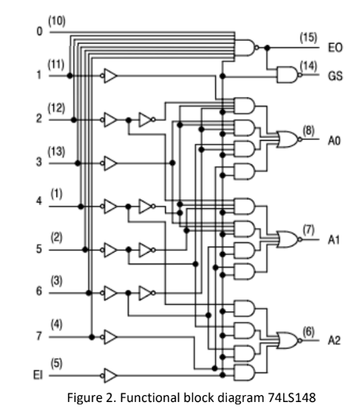

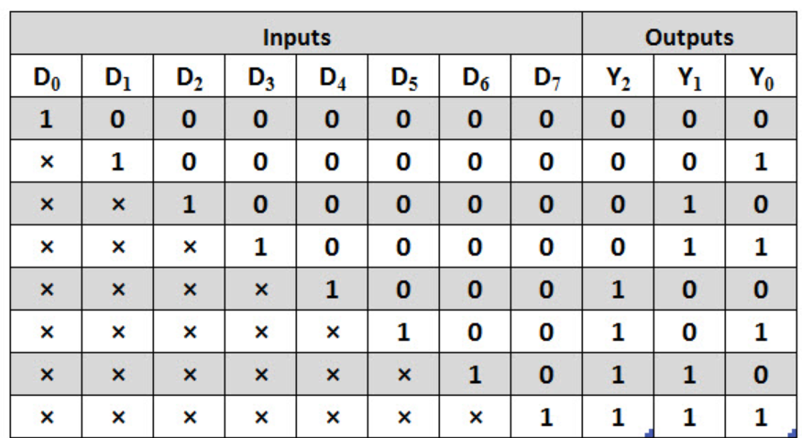

Decimal to BCD Priority Encoder (74147):

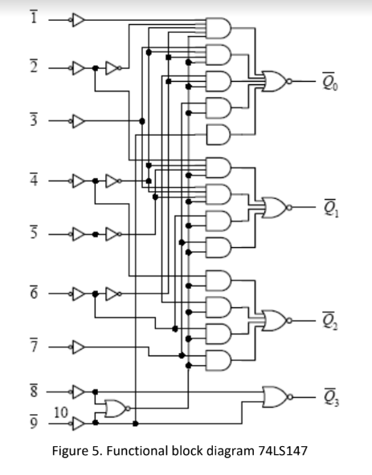

16 bit Octal to Binary Priority Encoder using 74148 IC.:

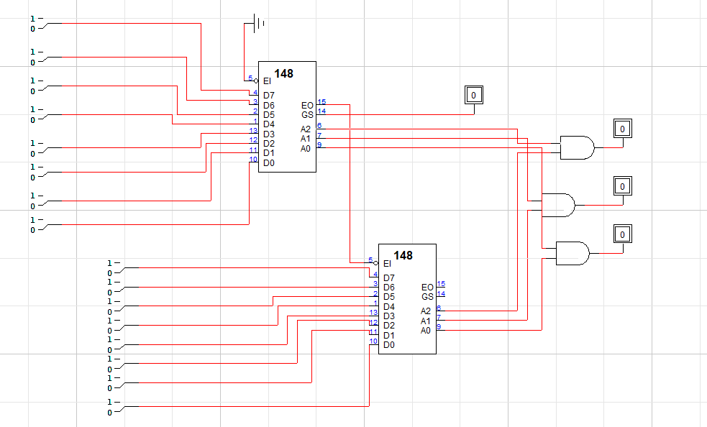

Implementation of 3-8-line Decoder using IC 74LS138:

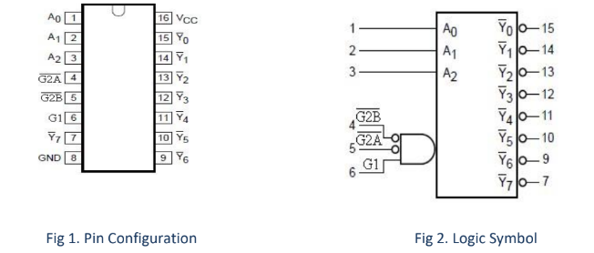

Implementation of BCD to Seven Segment Decoder using IC 74LS47:

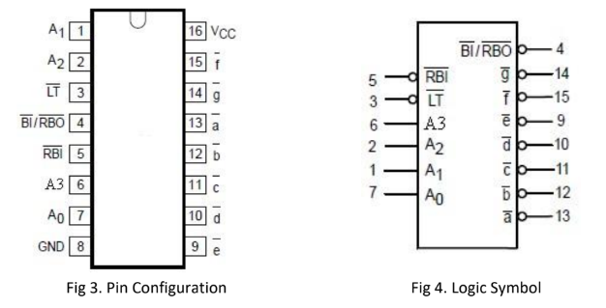

8x1 Multiplexer:

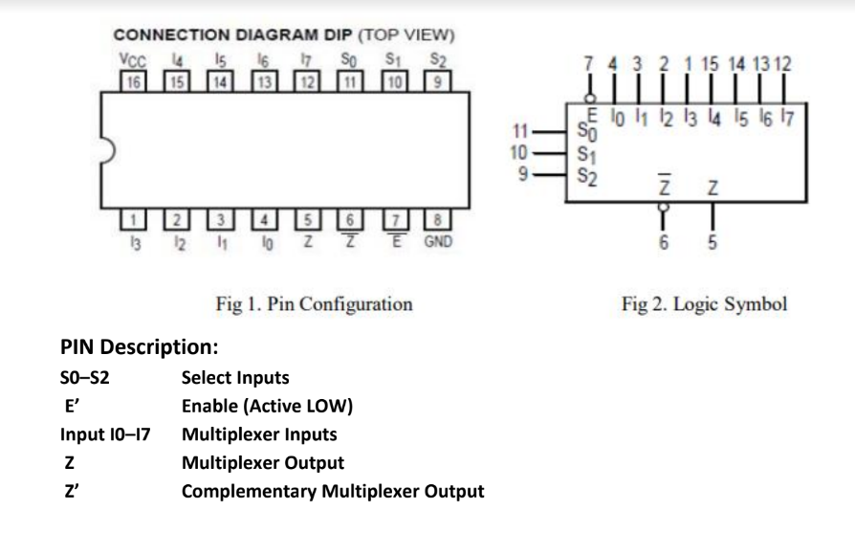

SR Latch Using NOR Gate:

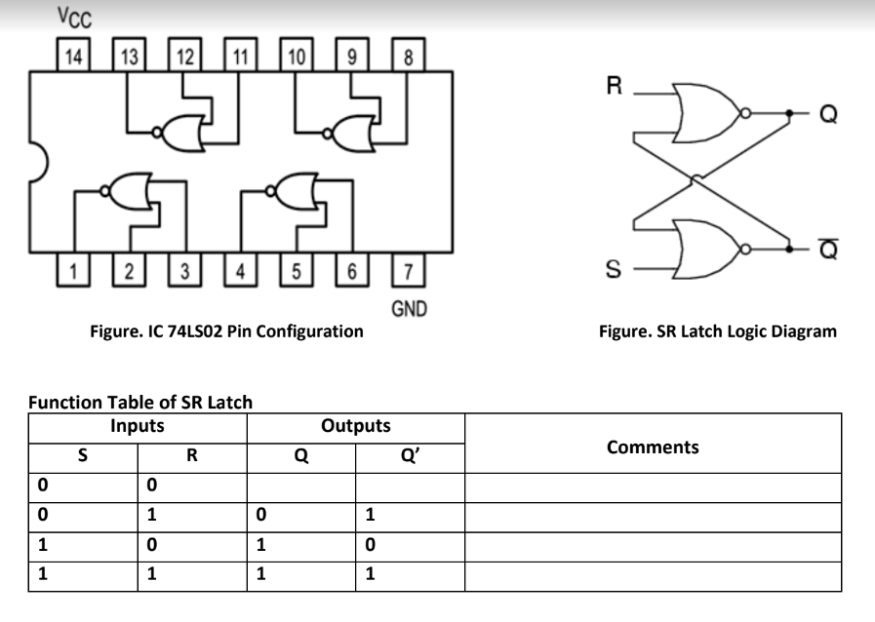

D Latch:

Edge Triggered D Flip-Flop:

JK Flip-Flop:

